Cover Page
Table of contents
Introduction
SOPS

ADMINISTRATOR

Systems installation
- Required Materials
  - Laptop or Desktop
  - Windows 10 and above operating system
  - 500 + GB storage
  - 8 GB RAM
  - Core -i5 processor 1.3 GHz +
  - 25-inch monitor for desktops – better view
  - Local Area Network connections or Wifi (for use with tables and phone)
- Server and Database
  - Apache Server 2.4 and above
  - Mysql-8.0.3-winx64 and above
- Download Apache servers and MySQL from official websites or folder in the link and extract using unzip software. Download link: https://drive.google.com/drive/folders/1L1a0NDPmEMZE7GNLnji4pAZPvSTxgoP-?usp=drive_link
- Install the server as an administrator by following the installation wizard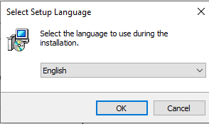
- Click Next for installation to complete. Once it is installed. Close the application
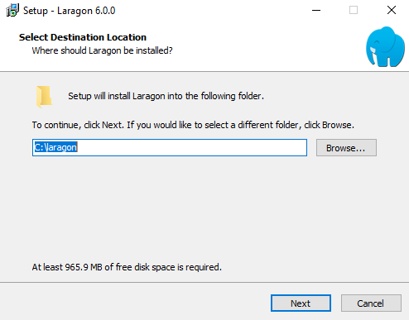
- Confirm if Laragon or whichever server (XAMPP or WAMP) is successfully installed by checking in the taskbar or search panel.
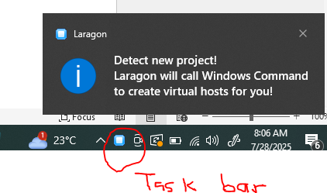
- This level will require internet connection to download the phpMyAdmin and install along
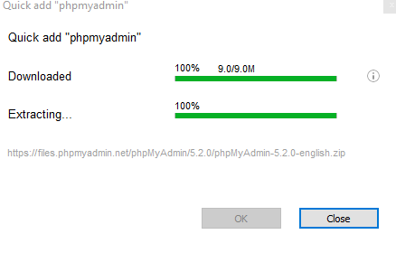
- This will open this page: Username: root
Password: leave blank
Click Login
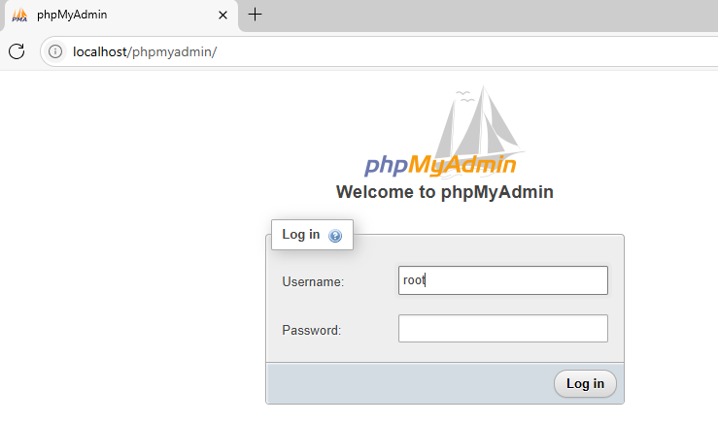
- Download the project folders from https://drive.google.com/file/d/1V8ywMDUk6NCiKcup9CaSP76vElru-WjK/view?usp=drive_link and unzip to the laragon folder www or htdocs for XAMPP and give it your desired name example: Methadone
This PC > Local Disk (C:) > laragon > www > IORPMS
This PC > Local Disk (C:) > XAMPP > htdocs > IORPMS
- This will open the following screen. Click on Databases and enter: methadone and choose utf8mb4_general_ci collation
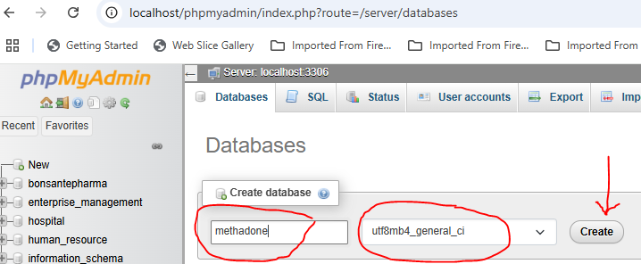
- Import database from the folder C:/laragon/www/IORPMS/backup/database/iorpms.sql
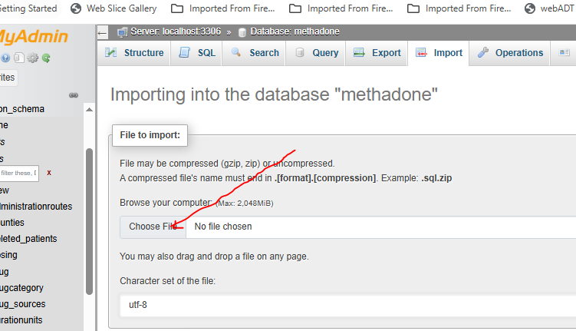
Type the following in url and press enter key http://localhost/iorpms/
- This will open the following screen
Username: admin
Password: 123456 and login

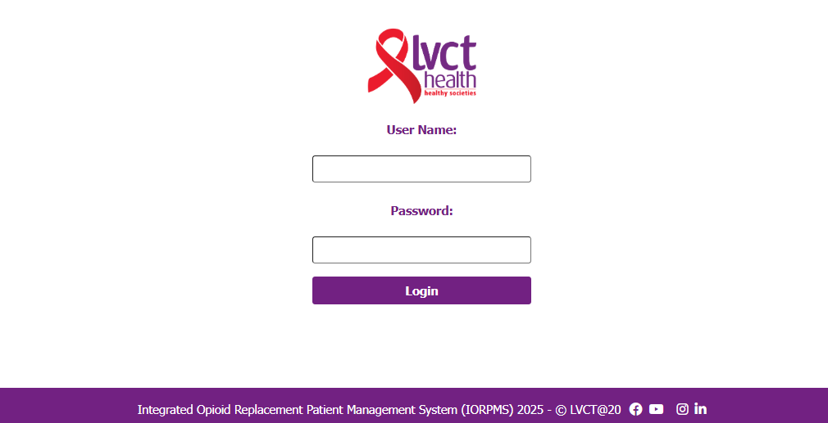
- This will open the following landing page which is home page:
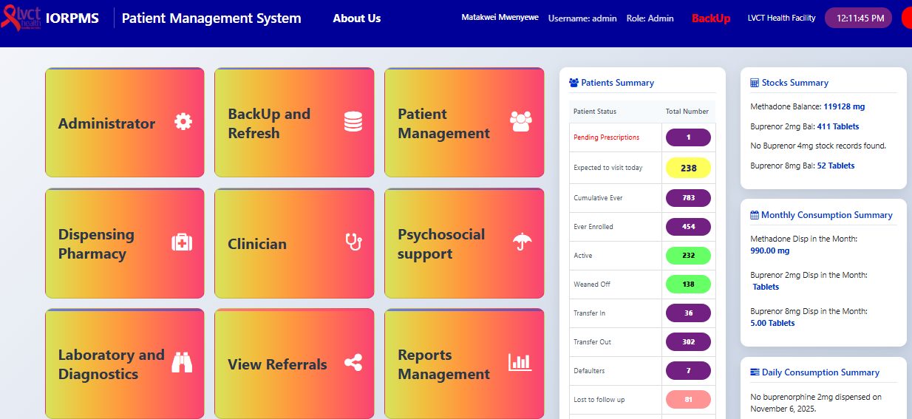
Disclaimer: You can now navigate to the module of interest. Not all users will see all modules

Facility initial setup
- Open Administrator module by clicking on it as shown is Systems installation procedure 13.
- Go to facility setup
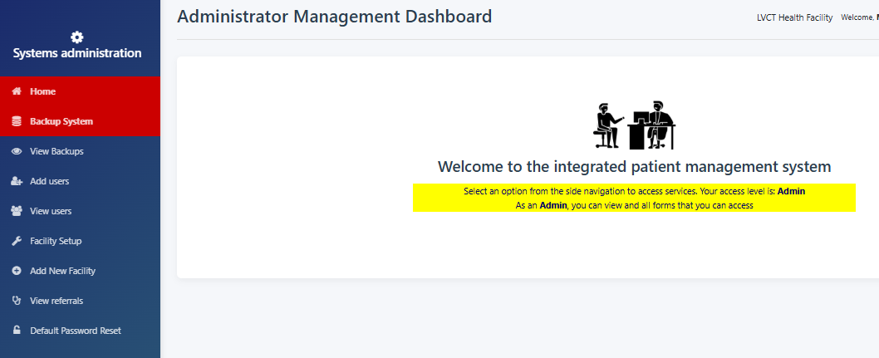
- Select the facility and other settings will auto-populate and then fill in the facility in charge, phone and email and save and submit
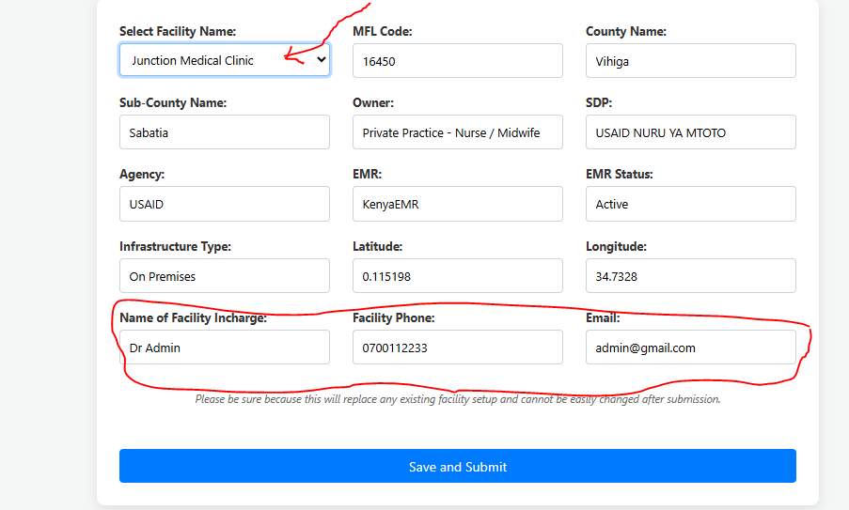
- Click home to navigate back to home page and you should see the facility name displayed:
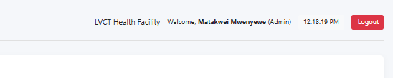

Backups
- Open Administrator module by clicking on it as shown is Systems installation procedure 13.
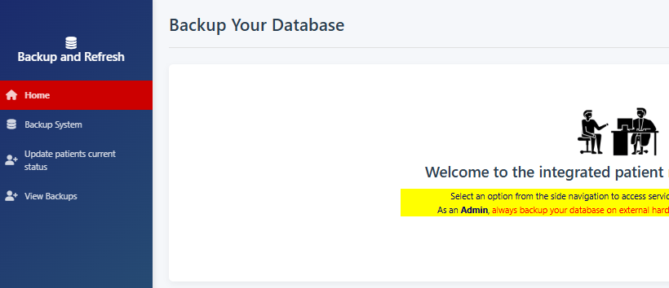
- Click on backup system and you should see success message
- Click view backups to see if the backup for the date is available
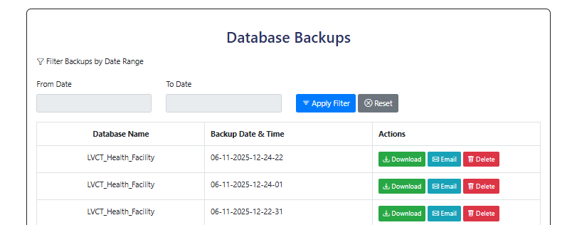
- Click on download button to download the backup into the downloads folder
- Click email to email the backup to the default email setup – still under development

Add users
- Click view users and search the name of the user you want to add
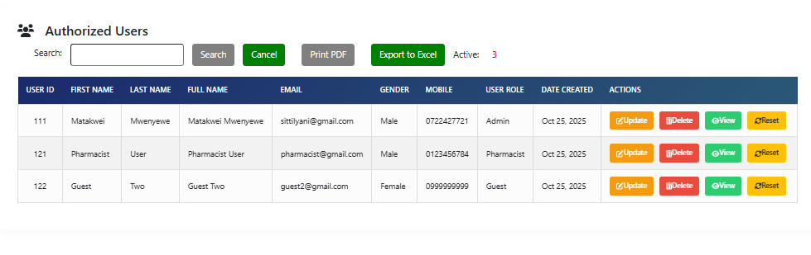
- If the user doesn’t exist then, then click Add Users tab
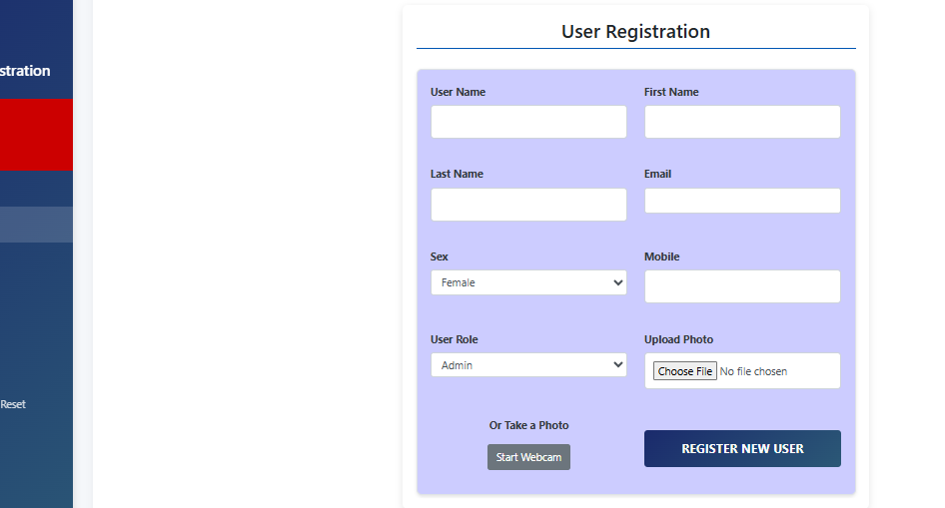
- Input all required fields and submit by clicking ‘REGISTER NEW USER’ button
- The system will automatically logout and you need to log in again
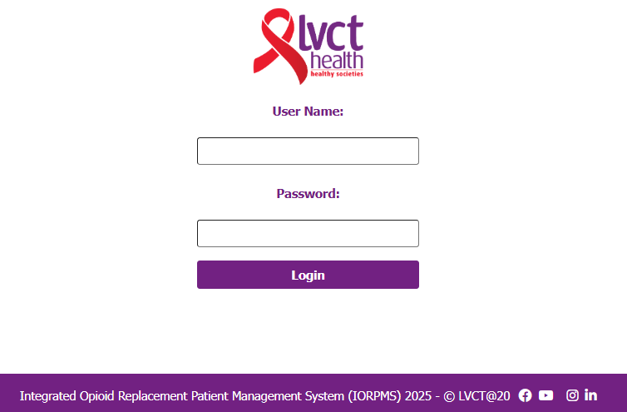
- Enter your created username and default password “123456” to login again

Change password
- Login the system and select profile module
- Click change password tab. Input 123456 as old password and input your preferred password and confirm by entering the same as new password and click update password
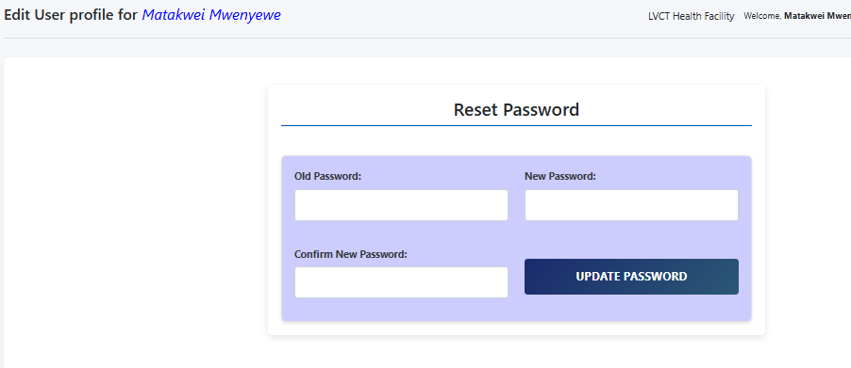

Referrals
- Click on view referrals to see all referrals submitted to different departments
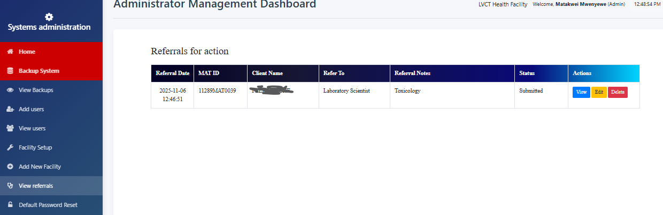
- Click view to see the prescription details. The submitted date prompts for action.
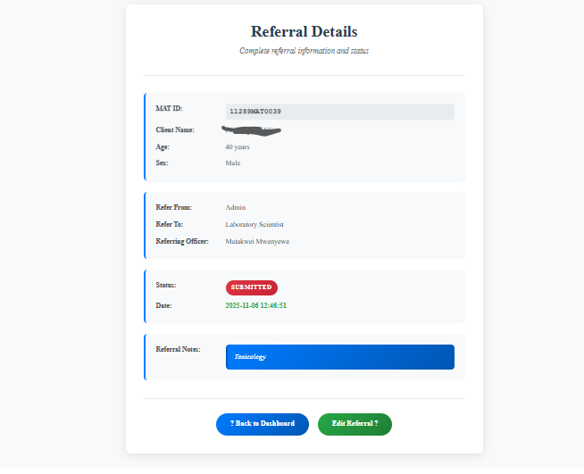
- Delete button deletes the referral
- View button displays the referral foe review or complete status
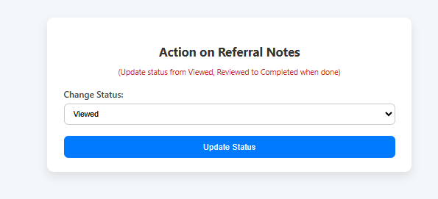

Password resets
- Click on the Default Password Reset tab to open the following:
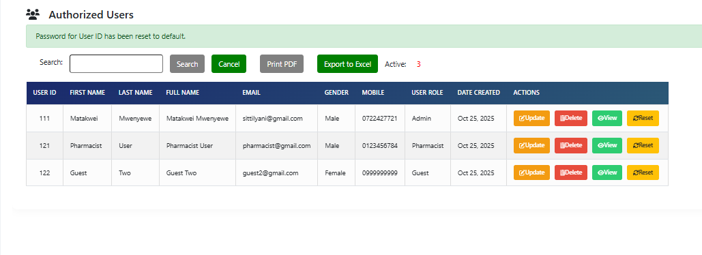
- Update button updates the user details except the username
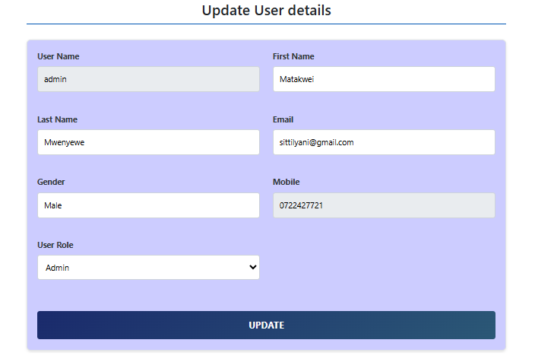
- View button views the user details and you can navigate back to users’ list
- Reset button resets the user password to “123456”
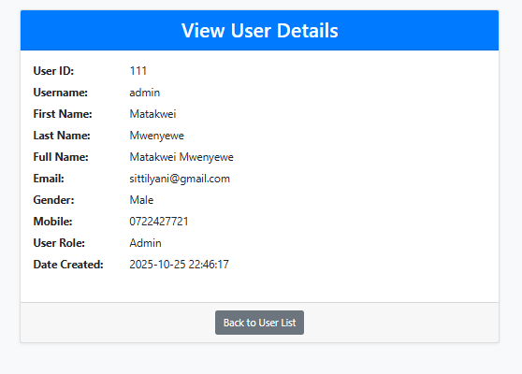

BACKUP AND REFRESH

Backup System
- Open Administrator module by clicking on it as shown is Systems installation procedure 13.
- Click on backup system and you should see success message
- Click view backups to see if the backup for the date is available
- Click on download button to download the backup into the downloads folder
- Click email to email the backup to the default email setup – still under development

Update patients’ current status
- Click on update patients’ current status if the system was not on and you will see output like this below
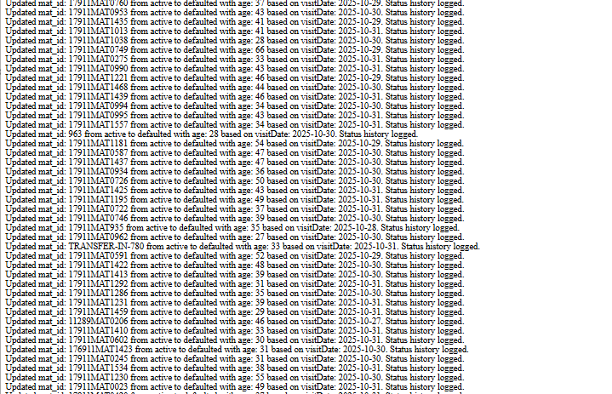
Active Patients who had missed more than 5 doses will change to defaulters
Defaulters who have missed more than 25 days from the day of default will change to LTFU (lost-to-follow-up)

View backups
- Click view backups to see if the backup for the date is available
- Click on download button to download the backup into the downloads folder
- Click email to email the backup to the default email setup – still under development

PATIENT MANAGEMENT
- Select the patient management module from the landing page
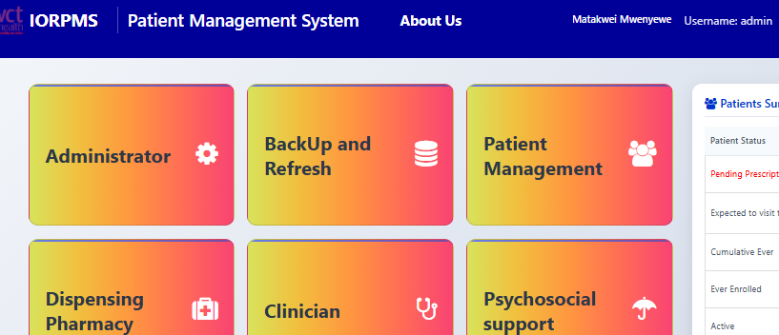

Register New Client
- Click on the Register New Client tab to open the following
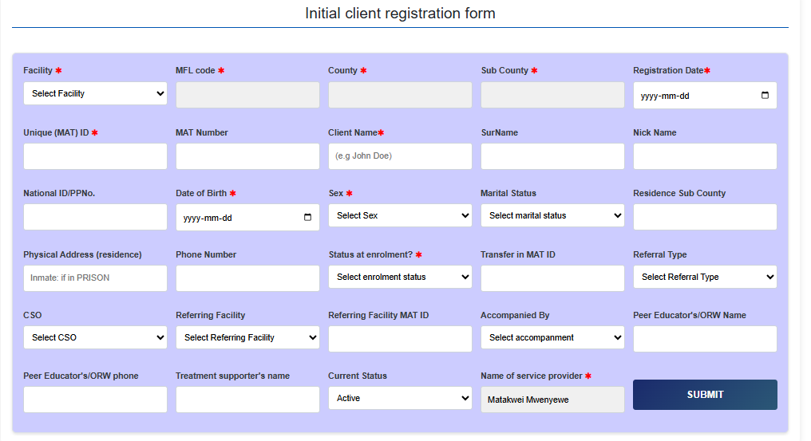
- Select facility name from drop down
- The MFLCode, County, Sub will auto populate from the database
- Select registration date which can’t be in future
- Unique MAT id uses MFLCode – MAT- 00001 or as per the clinic Standard operating Procedure example for LVCT Health clinic 99999MAT00001 where 99999 is MFLCode for Client number 00001
- For Transfer In clients use their existing MAT ID Number
- Client Name is example ‘John Doe’
- Select Date of Birth which should be at least 15 years
- Select sex
- Select enrolment status
  - New is Induction
  - Transfer In for clients from other facilities already on Methadone or Buprenorphine
  - Transit is for those clients who will be taking methadone or buprenorphine for not more than 30 days and go back to their MAT facilities
- Fields marked with asterisks are mandatory but if the registering officer has time, please update all fields
- The unfilled fields can be updated later

View Clients categories

DISPENSING PHARMACY

CLINICIAN

PSYCHOSOCIAL SUPPORT

LABORATORY AND DIAGNOSIS

VIEW REFERRALS

REPORTS MANAGEMENT

BIOMETRICS

PROFILE

APPOINTMENTS

